MATH V23 LECTURE NOTES (Bowen)  
Section 2.2  
Separable Equations

Unless otherwise stated, it will be assumed in this section that *x* is the independent variable, and *y* is the dependent variable, for each differential equation discussed.

At long last, we are about to learn (in the next several sections) how to find closed-form solutions to several classes of first-order ODEs. The first method, introduced in this section, relies on the basic integration techniques you learned in MATH V21B.

Solution by integration. You may recall from the last section that, for equations of the form



if the function *f* is a function of *y* only, the equation is called an autonomous equation. If, however, the expression on the right side of the equation is a function of *x* only (), the equation can be solved by multiplying both sides by *dx*, which converts the equation to differential form:



Provided that  has an antiderivative, a family of closed-form solutions may be obtained by simply integrating both sides and appending “” to the specific antiderivative. We may extend this technique to a wider class of functions , however, by noting that integration may also be used if *f* can be rewritten as the product of a function of *x* only and a function of *y* only; that is, if



This type of equation is said to be ***separable***, or to have ***separable variables***. Sometimes it is not initially obvious that an equation is separable. For example, consider the ODE



in which it appears that the *x* and *y* variables are hopelessly entangled with each other. However, by consulting a [table of trigonometric identities](http://academic.venturacollege.edu/mbowen/courses/handouts/h_essential_trig.pdf), we find (using one of the product-to-sum formulas) that the expression on the right side of the equals sign may be rewritten as



which is a separable equation, with  and . To solve this new equation, we start by using algebra to isolate all factors containing *y* or *dy* on the left side, and all factors containing *x* or *dx* on the right side. Multiplying both sides by  yields the differential forms

, or



Integrating (accomplished by slapping an integral symbol in front of both sides) gives



(If you forgot the antiderivatives of obscure trigonometric functions, check the brief table of integrals inside the front cover of the textbook [Zill].) In the above equation, we combined the constants of integration from both integrals into a single value of C (the parameter for the solution family) on the right side of the equation (you may place *C* on either side of the result). Note that we leave this result in implicit form (because we’d have significant difficulty trying to isolate *y*). Also note that this solution is not valid for , because neither  nor  are defined there. I will call these *y* values “forbidden zones.” However, the interval of validity for a given solution is , as can be seen from using wxMaxima’s “plotdf” function to visualize the family of solutions. (See the [lecture notes from section 2.1](http://academic.venturacollege.edu/mbowen/courses/handouts/h_v23_lecnotes_2.1.docx) for more information on wxMaxima and “plotdf.”) Here is sample wxMaxima command syntax for the ODE in this example:

load("plotdf");

plotdf(2*cos(x)*cos(y),[xfun,"acos(-1)/2;-acos(-1)/2;3*acos(-1)/2;  
-3*acos(-1)/2"]);

After loading “plotdf” in the first command above, I have appended an “xfun” statement (the square brackets, semicolons, and quotes are a required part of this statement) to wxMaxima’s “plotdf” command. (You should be able to copy-and-paste directly from the above code block directly into a blank wxMaxima window if you have difficulty typing the detailed syntax manually.) The “xfun” feature allows the user to overlay the graphs of one or more user-specified functions of *x* onto the direction-field plot generated by “plotdf.” In this case, I am using “xfun” to graph horizontal lines to mark the forbidden zones and  on the direction-field plot. Unfortunately, the “xfun” statement sends the user function(s) to an interpreter called TCL, which does not understand the concept of . However, TCL is aware of trig functions and their inverses, so I am using  (which in TCL syntax is written acos(-1)) as a poor man’s substitute for , then multiplying this expression by  and  to obtain the forbidden *y* values. This is what gave rise to the more complicated syntax seen above. (Remember to use SHIFT+ENTER, not just ENTER, to instruct wxMaxima to execute a command.)



With these additional graphs, we may see where the “forbidden zones” are located on the graph (dark horizontal lines), and investigate the behavior of members of the family of solutions near these zones (note how the red solution curves seem rather anxious to avoid the forbidden zones). The screen-grab below exhibits some solution curves I obtained using the above commands (when in wxMaxima, click directly on the plot to interactively create the red curves), as well as the graphs of some of the forbidden zones.

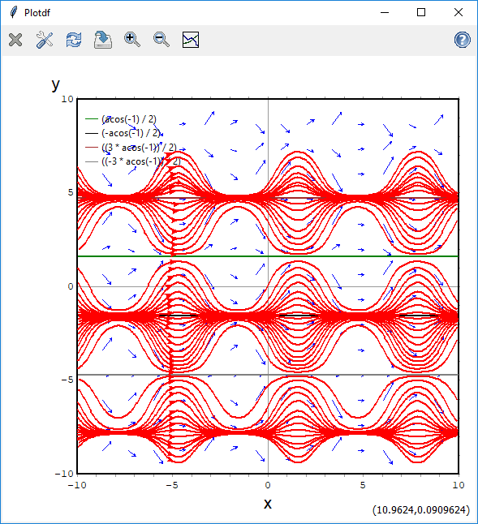

Initial value problems. We may select one member of the family of solutions by specifying an initial value. Example: solve

, 

Multiply both sides of the first equation above by  to separate the variables:



Then distribute the right-hand side, and integrate (solving the first integral using the substitution ):







Finally, substitute the initial value information  into the general solution above to find the value of *C* and the corresponding specific solution:





Although we could, in principle, obtain a closed-form solution without undue difficulty by isolating *y*, the implicit formula obtained in the last step would likely be sufficient for most practical purposes.

Losing a solution. See example 3 in the textbook for a discussion of how singular solutions may be lost during the separation-of-variables process. Here is another example:



For practice, try to show, using separation of variables, that the general solution is



Because we divided both sides by , we lost the possible solution  (because if we had assumed that , it would have meant that we were dividing both sides of the equation by zero). This additional solution (which we may verify by direct substitution) is not a member of the preceding family of solutions, so it is a singular solution. We must add this singular solution to our list before claiming that we have found a *complete* list of solutions to the ODE. In general, whenever you divide both sides of an ODE by a function of *y* which includes zero in its range, you should check for singular solutions of the form  by substituting appropriate constants into the *original* ODE to see whether they are also solutions.

This peculiarity arises from the nature of algebra, and its effects are not limited just to the study of differential equations. For example, if you were to start solving the algebra equation



by dividing both sides of the equation by *x*, you would obtain



However, the original problem was a third-degree (cubic) equation, so the Fundamental Theorem of Algebra insists that we should have obtained three solutions, not just two. Sure enough, if we re-examine the *original* equation, it is easy to verify (by direct substitution) that  is the “missing” third solution, but it was “lost” when we divided both sides of the equation by *x*. You must train yourself to be aware of, and search for, these additional “lost” solutions before claiming that you have found every solution of any equation (including a differential equation).